# Image result for credit card list Image result for storage mediaImage result for storage mediaImage result for ssdC:\Users\bailes\AppData\Local\Microsoft\Windows\INetCache\Content.MSO\2EE3DEAC.tmp

# Purpose

The purpose of this assignment is to get some experience with handling **text** **files** and dealing with **exceptions**. The context of this assignment is an extension of the **CreditCardList** project. The project will involve saving the information from a **CreditCardList** into a text file and populating a **CreditCardList** from a text file.

## Disclaimer

It is never a good idea to save your credit card information in an ordinary humanly readable text file because anyone with access to your computer could easily get all of your credit card data. In reality, this information should be saved in an **encrypted** data base or other **encrypted** data store, but encrypting the data is beyond the scope of this project. Even though we are saving the data in a plain text format for this assignment, we should not do that for a real-world project.

# Specifications

Expand your **CreditCardList** class to include at least two additional methods.

* A **constructor** that takes a string parameter containing the file (and path) information for a Credit Card text file. The constructor should populate the **CreditCardList** from the data in the text file.
* A **Save** method that also takes a string parameter containing file (and path) information for a Credit Card text file. This method should save all of the information from the **CreditCardList** into the specified text file.

File-handling code is a potential source of **exceptions**. Handle all potential **exceptions** in your code so that the program does not crash as the result of an exception. Your exception handling logic should be reasonable for the situation. For example, if the program is unable to open the specified file, it would not be reasonable to simply allow the program to continue to try to process the file as that will only lead to more exceptions.

The class needs a **private** **boolean** **attribute** named **saveNeeded** that is initially **false**. It should be set to **true** whenever a change is made to the **CreditCardList** (new credit card added, credit card deleted, the list is sorted, and so forth). It should be set to **false** when the list is first created and after every time it is saved. This attribute should have a **public** **getter** (not a public setter) that allows a user of the class to find out if the current **CreditCardList** needs to be saved.

As always, all interaction with the user should occur in the **driver** class. This means that **catch** **handlers** may need to be in the **main** or other method in the driver class if these handlers intend to interact with the user in any way). File input and output should be handled in the **CreditCardList** class (or a separate class whose job is to handle all file I/O).

The **driver class** should be expanded to allow for the newly added functionality in the **CreditCardList** class. For example, it should use a **JFileChooser** to select the file from which a new list will be populated or to which a list is to be saved. Once the driver has the file (and path) information for the file, it will pass that information along to the appropriate **constructor** or **Save** method in the **CreditCardList** class. You may or may not need to add or modify menu choices.

The **driver** should save the **CreditCardList** into a user-selected **text** **file** every time a new list is created or populated from a text file (if **saveNeeded**). It should also save the **CreditCardList** into a user-selected text file whenever the program is about to exit (again, if **saveNeeded**).

Put all of your **.java** files into your Java **package** from earlier projects. This is represented in your **src** **folder** as a **subfolder** named the same as the **package**. Your project may have multiple packages (for example **creditCards** and **util)**.

# Test Data for This Project

Using a text editor such as **NotePad++** or even the **editor in Eclipse**, create a pipe-character (**|**) delimited text file for use in testing your solution. Place this file in a folder named **CreditCardData** that is part of your **Eclipse** **project** but **outside** of other **subfolders** such as **src** or **bin**. For example:

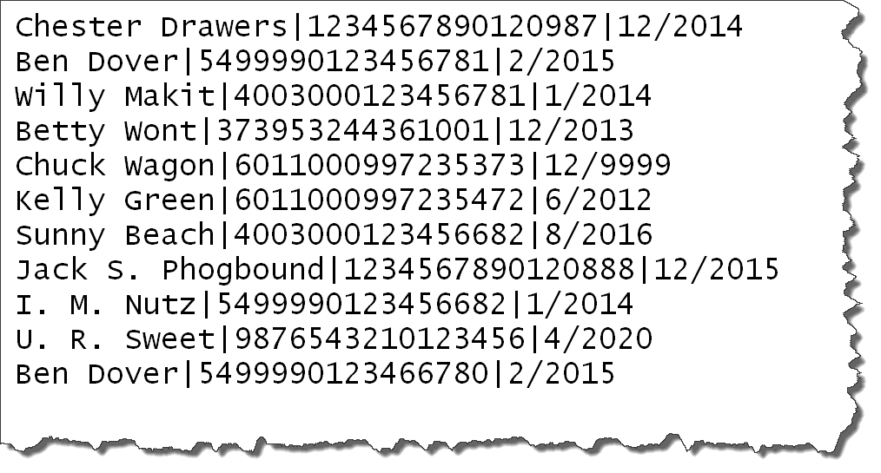

Make sure your text file is in the same format as the example so that when your program is tested against another text file, it will be able to handle the different data.

Make sure your **JFileChooser** dialogs initially start in the **CreditCardData** folder of your project.

# Deliverables

As with your previous assignments, the initial design is due in one week and the final solution including the final design and your test data files are due in two weeks. Specific dates are given on the course web site. Follow submission rules in the Course Facts. Your project submission should include:

* All .**java** files in the folder representing the **package** you used. The entire **subfolder** will be included in your zipped submission. You may have multiple packages included in the same .zip file.
* The **final** **design** **document**
* Your **test** **data** **file**(s) and their containing folder
* For example, a project like this would contain 3 folders (**creditcard, util, and CreditCardData**) and the **final design document** all zipped into the single file to be submitted.

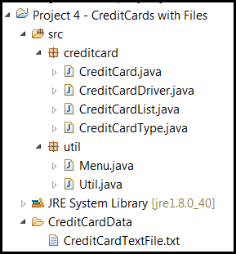

All of these items should be in a single zipped file that is named appropriately.